

Lease Deed - User Stories & Wireframes

Contents
User Stories- Lease Deed Process 3
1. User Story- Add Lease Deed Details 3
1.1 Mock-ups 4
2. User Story- Edit Lease Deed Details 5
2.1 Mock-ups 6
3. User Story- View Lease Deed Details 7
3.1 Mock-ups 8
4. User Story- Generate Property Checklist 8
4.1 Mock-ups 9
5. User Story – Generate Lease Rent Challan 11
5.1 Mock-ups 12
6. User Story- Calculate Lease Rent 13
6.1 Mock-ups 14
7. User Story – Generate Lease Rent Schedule 15
7.1 Mock-ups 16

User Stories- Lease Deed Process

User Story- Add Lease Deed Details

Sprint | 4
User Story ID | 001
User Story Title | Add Lease Deed Details
Actors | Department user
Story | As a department user, I want to add lease deed details for a property in system.
Pre Conditions | - User should have required access rights.
Business Criteria | - Lease deed would only be executed if there are no due till date.  - Lease rent would start after the successful completion of lease deed.
Acceptance Criteria | - User would click on “Add Lease Deed” button under the lease deed menu.  - User would get a form with label as “Add Lease Deed Details”. User would then select “Property number” from the dropdown and would be displayed with below fields:  - Allottee Name: Label  - Property Cost: Label  - Previous Dues (INR): Label  - Balance on Installment (INR): Label  - Lease Deed Stamp Value (INR): Label  - Duplicate Stamp Value: Label  - Total Due (INR): Label  - Lease Deed Due Date: Label  - Lease Deed Execution Date: Date Mandatory.  User would update the lease deed execution date for the selected property number.  - User would click on the “Submit” button to execute lease deed for a property and details would be displayed in grid on “Lease Deed” screen. Alternatively, on clicking the “Cancel” button system would return the user to the lease deed screen without saving the details.  - Grid will display following columns:  - Property Number  - Lease Deed Status  - Amount Due  - Lease Deed Due Date  - Lease Deed Execution Date  - Action: Edit
Field level Validation

Mock-ups

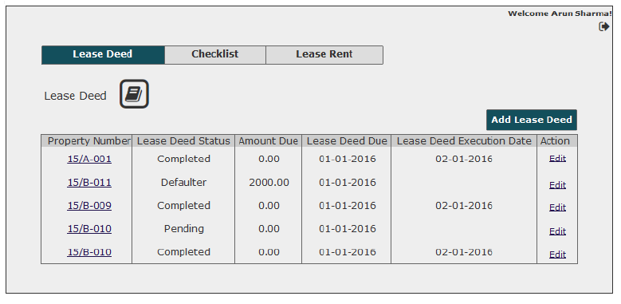
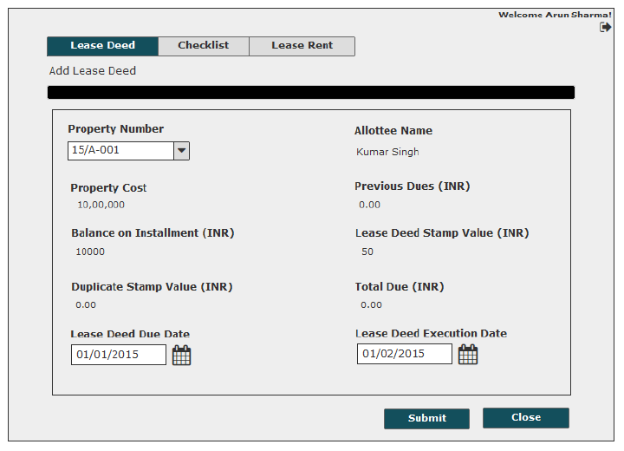

User Story- Edit Lease Deed Details

Sprint | 3
User Story ID | 002
User Story Title | Edit Lease Deed Details
Actors | Department user
Story | As a department user, I want to edit lease deed details for property.
Pre Conditions | - User should have required access rights.
Business Criteria | - Lease deed would only be executed if there are no due till date.  - Lease rent would start after the successful completion of lease deed.
Acceptance Criteria | - User would click on the “Edit” option available in the grid against each details property lease deed details added.  - User would get a pre-filled form with the following fields:  - Property Number: Dropdown, mandatory  - Allottee Name: Label  - Property Cost: Label  - Previous Dues (INR): Label  - Balance on Installment (INR): Label  - Lease Deed Stamp Value (INR): Label  - Duplicate Stamp Value: Label  - Total Due (INR): Label  - Lease Deed Due Date: Label  - Lease Deed Execution Date: Date Mandatory.  - After updating the form, user would click on submit button to update lease deed details successfully and updated details would be displayed in grid on lease deed screen. Alternatively, on clicking ’Cancel’ button, system would return the user to the lease deed screen without saving the updated details.
Field level Validation

2.1 Mock-ups

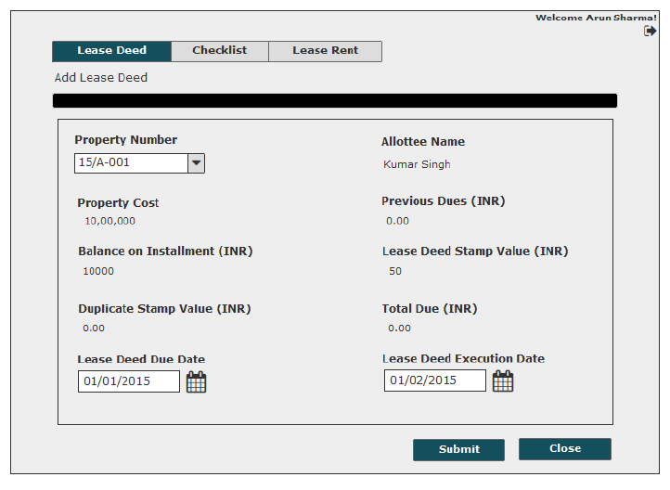

User Story- View Lease Deed Details

Sprint | 4
User Story ID | 003
User Story Title | View Lease Deed Details
Actors | Department user
Story | As a department user, I want to view lease deed details.
Pre Conditions | - User should have required access rights.
Business Criteria
Acceptance Criteria | - User would click on “Property Number” hyperlink option available in grid for viewing the lease deed details.  - User would get screen with complete lease deed information of the selected property:  - Property Number  - Allottee Name  - Property Cost  - Previous Dues (INR)  - Balance on Installment (INR)  - Lease Deed Stamp Value (INR)  - Duplicate Stamp Value  - Total Due (INR)  - Lease Deed Due Date  - Lease Deed Execution Date  - After viewing the details, user clicks on the “Close” button and system would return the user to the lease deed screen.
Field level Validation

Mock-ups

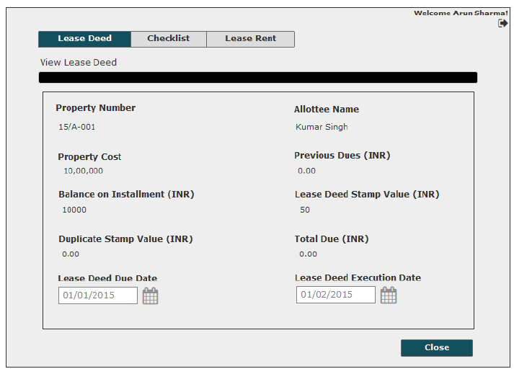

User Story- Generate Property Checklist

Sprint | 4
User Story ID | 004
User Story Title | Generate Property Checklist
Actors | Department user
Story | As a department user, I want to generate checklist for particular department and property type.
Pre Conditions | - User should have required access rights.  - Printer should be connected to the LAN.
Business Criteria | - Generation of checklist will take place for all departments except housing and residential.
Acceptance Criteria | - User would click on “Checklist” from the navigation panel and would get a form.  - User would then select “Department” from dropdown and then “Property Type” from dropdown available on the form.  - User would then click on “Generate Checklist” button. The system would then generate and display the checklist on the application screen.  - User would have the options to save the file to his local system by clicking on ‘Save’ button or print checklist by clicking on ‘Print’ button.
Field level Validation

Mock-ups

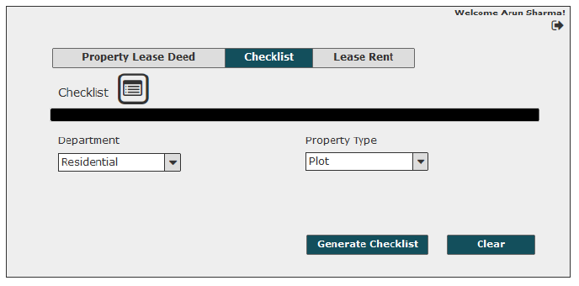
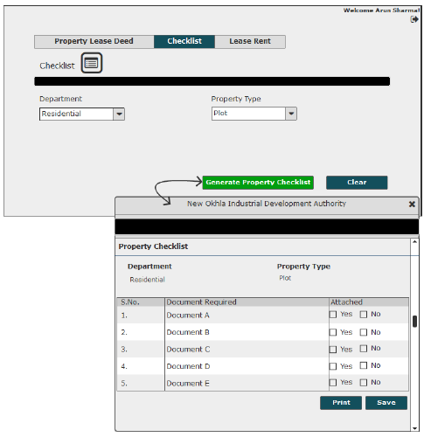

User Story – Generate Lease Rent Challan

Sprint | 4
User Story ID | 005
User Story Title | Generate Lease Rent Challan
Actors | Department user
Story | As a department user, I want to generate lease rent challan for particular property number.
Pre Conditions | - User should have required access rights.  - Printer should be connected to LAN.
Business Criteria | - Lease rent would be calculated as per below options:  First option, the allottee can pay the lease money every year. In this instance, lease money is defined percentage of property area multiplied by the current circle rate.  Second option, the allottee can pay lease rent of current year and multiply it with a certain number of years (as decided by the authority from time to time) and that would be considered as ONE TIME lease rent, which is equivalent to lease rent for entire lease duration of a defined time-frame.  Formulas for reference:  [Per Year Lease Money= (PA*CR*PER)/100]  where,  PA=Property Area (Sq.mtr)  CR=Circle Rate  PER=Defined % by authority Rules  One time Lease Money=Per Year Lease Money*Define Year by authority
Acceptance Criteria | - User would click on the “Lease Rent” from the navigation panel and would get a form.  - The form would contain the below field and action buttons:  - Property Number: Dropdown, Mandatory to fill  - Lease Rent Challan button  - Calculate Lease Rent button  - Lease Rent Schedule button  - User would then select property number from the dropdown menu available on the form.  - User would then click on “Lease Rent Challan” button. The system would then generate and display the lease rent challan on the application screen.  - User would have the options to save the file to his local system by clicking on ‘Save’ button or print challan by clicking on ‘Print’ button.
Field level Validation

Mock-ups

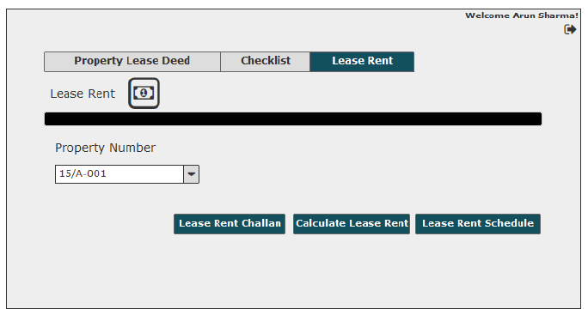
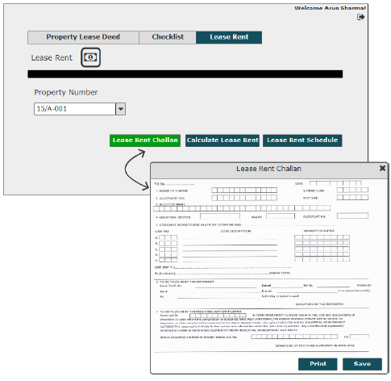

User Story- Calculate Lease Rent

Sprint | 4
User Story ID | 006
User Story Title | Calculate Lease Rent
Actors | Department user
Story | As a department user, I want to calculate the lease rent amount for a property.
Pre Conditions | - User should have required access rights.
Business Criteria | - Lease rent would be calculated as per below options:  First option, the allottee can pay the lease money every year. In this instance, lease money is defined percentage of property area multiplied by the current circle rate.  Second option, the allottee can pay lease rent of current year and multiply it with a certain number of years (as decided by the authority from time to time) and that would be considered as ONE TIME lease rent, which is equivalent to lease rent for entire lease duration of a defined time-frame.  Formulas for reference:  [Per Year Lease Money= (PA*CR*PER)/100]  where,  PA=Property Area (Sq.mtr)  CR=Circle Rate  PER=Defined % by authority Rules  One time Lease Money=Per Year Lease Money*Define Year by authority
Acceptance Criteria | - User would click on the “Lease Rent” from the navigation panel and would get a form.  - The form would contain the below field and action buttons:  - Property Number: Dropdown, Mandatory to fill  - Lease Rent Challan button  - Calculate Lease Rent button  - Lease Rent Schedule button  - User would then select property number from the dropdown menu available on the form.  - User would then click on “Calculate Lease Rent” button. The system would display the calculated lease rent amount on the pop up window.  - On clicking on the “ok” button the pop up window will be closed and user will return on the lease rent screen.
Field level Validation

Mock-ups

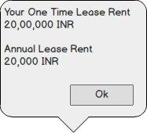

User Story – Generate Lease Rent Schedule

Sprint | 4
User Story ID | 007
User Story Title | Generate Lease Rent Schedule
Actors | Department user
Story | As a department user, I want to generate lease rent schedule for selected property.
Pre Conditions | - User should have required access rights.
Business Criteria | - Lease rent would be calculated as per below options:  First option, the allottee can pay the lease money every year. In this instance, lease money is defined percentage of property area multiplied by the current circle rate.  Second option, the allottee can pay lease rent of current year and multiply it with a certain number of years (as decided by the authority from time to time) and that would be considered as ONE TIME lease rent, which is equivalent to lease rent for entire lease duration of a defined time-frame.  Formulas for reference:  [Per Year Lease Money= (PA*CR*PER)/100]  where,  PA=Property Area (Sq.mtr)  CR=Circle Rate  PER=Defined % by authority Rules  One time Lease Money=Per Year Lease Money*Define Year by authority
Acceptance Criteria | - User would click on the “Lease Rent” from the navigation panel and would get a form.  - The form would contain the below field and action buttons:  - Property Number: Dropdown, Mandatory to fill  - Lease Rent Challan button  - Calculate Lease Rent button  - Lease Rent Schedule button  - User would then select property number from the dropdown menu available on the form.  - User would then click on “Lease Rent Schedule” button. The system would then generate and display the lease rent schedule on the application screen.  - User would have the options to save the file to his local system by clicking on ‘Save’ button or print the schedule by clicking on ‘Print’ button.  - User can close this screen by clicking on the “Close” button and user would return on lease rent screen.
Field level Validation

Mock-ups

